Description on how to download historical continuous daily futures data from acommodity.com:

Historical continuous daily futures data are available on acommodity.com. acommodity provides some free futures data from barchart.com. Symbols may be found at:
https://www.barchart.com/futures/major-commodities

Set-up:

- Verify that the following line exists in the “mywebserver.txt” file. Otherwise, append it to the file.

Futures_Acommodity_D,http://customer1.barchart.com/cgi-bin/mri/webplt.exe?ccharts=Y&page=chart&sym=SSSS&data=B&date=MMMMDDDDYY2Y&size=b&den=med&jav=asc&expm=15&vol=Y&sly=N&ch1=011&arga=&argb=&argc=&ov1=&argd=&arge=&argf=&ch2=&argg=&argh=&argi=&ov2=&argj=&argk=&argl=&code=efutur&org=com&crea=Y,DWML2,Acommodity_DWML2.fmt
- You can control when the data start to roll to the next nearest contract. In the above line where the Expiration Mode shows the default value, expm=15, data start to roll to the next nearest contract 15 days prior to the expiry of the current contract. Modify this parameter as you wish with the following guide:
Expm=0 Not selected
=W Last Week
=M Last Month
=3 3 days
=5 5 days
=9 9 days
=15 15 days
=20 20 days
=30 30 days

- Copy the “Acommodity_DWML2.fmt” file to the “fmt” subfolder, if it is not already there.
- Run HSQuote Plus and set up the screen as shown. Make sure the portfolio ticker name is exactly “Futures_Acommodity_D.tic”. Choose “My Web Server (Plus)” as the Server. You may add or delete ticker symbols.
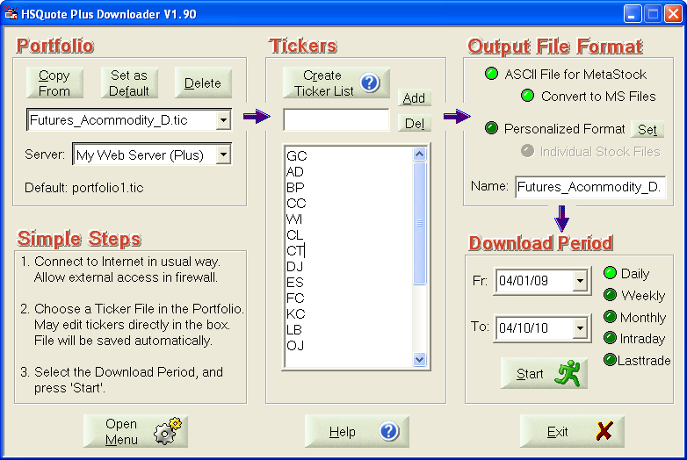

Historical Daily Data Download:

Just select the Download Period, and “Start”. You will get futures data in MetaStock data files, stored in the data file location under the portfolio name subfolder. If you click on “Open Menu >> MetaStock Data and Chart”, you will see the data or chart.

Acommodity provides about two years of data from the To-Date indicated on the main screen for each download. To gather all the older data, you will need to download several times, with different Fr-Dates and To-Dates two years apart.

